St. Catherine of Siena
Fall Retreat 2015
Who: All High School Students (9th-12th Grade)
When: Friday, Nov. 6th to Sunday, Nov. 8th
Where: Life Teen Camp Hidden Lake in Dahlonega, GA
Cost: Early Bird/$100.00 if you sign-up before Mon. Oct. 26th
Regular/ $150 if you register on/after Mon. Oct 26th
Last Day to Sign-Up: Monday, November 2nd

Meet at St. Catherine's for check-in and loading at 6:00 pm on Friday, Nov. 6th
Departure from St. Catherine’s to Life Teen Hidden Lake will be at 6:30 pm
*Please eat dinner before you arrive on Friday*

Hidden Lake is a Catholic Camp that was purchased by Life Teen in the Fall of 2014. Owned and operated by Life Teen, the primary purpose for this retreat site is to create an atmosphere that is both inviting and welcoming of the Holy Spirit so that teens are given an awesome chance to encounter Christ in their lives. Anyone who has been to Camp Hidden Lake can attest to both how beautiful it is and how much God has worked through it in the short time that Life Teen has been using it.

830 Hidden Lake Road, Dahlonega, GA 30533
Phone Number: (706) 867-0592
What to Bring:  Clothing  Comfortable & Appropriate Clothes (t-shirts/jeans/sweater/PJs)  Closed-toe shoes for hiking (sneakers)  Toiletries  Toothbrush/Toothpaste  Shower Shoes/Towel/  Shampoo/Conditioner/Soap/Wash Cloth/Deodorant  Bedding  Either a sleeping bag and twin flat sheet  or twin sheets and a blanket  Pillow  Extra’s  Flashlight/Rosary/ Bible/ Journal  Snack to Share:  Bring one snack (chips/cookies/granola bars) to be collected and put out during snack time. | What Not to Bring  Cell Phones/I-Pads/Tablets/Computers/Electronics  Any alcohol or tobacco products  Expensive jewelry or clothing
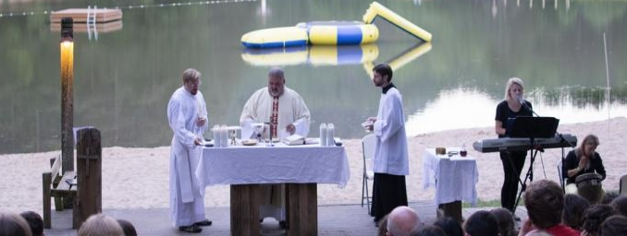
Any Questions?

Kristi Parr
Director of Youth Ministry
678-385-9433
kristip@stcatherinercc.org
What to Expect:
Small Groups and Faith-Building Sessions

Praise & Worship

Times for Individual and Collective Prayer

Skits, Games, and Indoor/Outdoor Activities
Free Time

Opportunity for Fellowship and Community

Virtuous Friendships Rooted in Christ

Catholic Archdiocese of Atlanta
St. Catherine of Siena Roman Catholic Church
Parental Consent and Medical Release Form

Life Teen Fall Retreat 2015-2016
Friday, November 6th through Sunday, November 8th
Life Teen Camp Hidden Lake 830 Hidden Lake Road, Dahlonega, GA 30533
Registration will begin at St. Catherine’s at 6:00 pm on Friday, Nov. 6th. Departure is at 6:30 pm.
Pick up is at 6:00 pm after the 5:00 pm Life Teen Mass at St. Catherine’s on Sunday, November 8th.

I/We the parent(s) of: (please print)_______________________________________________________________ do hereby give my/our approval for him/her to participate on Fall Retreat 2015 that is sponsored by St. Catherine of Siena Life Teen. I/We do hereby, for myself, my heirs, executors, and administrators, waive, release, absolve, indemnify and agree to hold harmless any and all adults who chaperone, also the Archdiocese and its representatives, successors, supervisors, sponsors, organizers and participants for any injuries in connection with the program named above. I likewise release from my responsibility any person transporting my child to and from any of the activities. I/We hereby grant permission for publication of group (two or more persons) photos taken at youth events.

I/We also give permission to seek any emergency care should my child be involved in any accident or be injured in any way during such events named above. I/We understand that in any such instance, all attempts will be made to contact the parent/guardian. In the event that I/we cannot be contacted, I/we hereby give permission to the attending physician to hospitalize, secure treatment for, and to order injection, anesthesia, and/or surgery for my child, as named herein.

I also agree that I am legally responsible for all/any personal actions taken by my child/guardianship during this event, and agree to be financially responsible for any/all damages, legal fees, and other costs incurred as a result of the actions/behavior of my child/guardianship.

Furthermore, I/we agree that if the above named student’s behavior is inappropriate, unsafe and/or detrimental to the group, I will be contacted immediately to secure means of removing my child/guardianship from the event premises. I understand that any financial costs incurred as a result of my child/guardianship being sent home are my responsibility.

Insurance Carrier: ____________________________ Policy #:________________________________________

Insurance Phone #: _____________________________ Child’s Birthday: ________________________________

Parent Cell: __________________________________ Parent Name: ________________________________________

______By initialing here, I grant permission for non-prescription medications to be given, if deemed appropriate by adult chaperone(s).

My child is allergic to: ____________________________ Current medication (and dosage): ________________________

Other medical, physical, or general information: __________________________________________________________________

In Emergency, Notify: ______________________________________ Phone: ___________________ Relation: _____________

Parent/Guardian signature:________________________________________ Date:_____________

Printed Name:________________________________________ Relationship: _____________________________

In signing this form, I certify that all information contained herein is true and accurate to the best of my knowledge.

